

**Student Activities for**

***The Story of North Carolina***

***The following activities were designed with the purpose of better engaging student visitors in the content of the NC Museum of History’s “Story of North Carolina Exhibit.” However, all activities can be altered for use with any museum or historic site visit, or for use with virtual/online exhibits in the classroom. If you have questions or need assistance with these activities, contact Christie Norris at*** [***cnorris@unc.edu***](mailto:cnorris@unc.edu)***.***

**Be a Museum Detective!**

In addition to preparing students for their museum visit by going over what to anticipate, behavior expectations, logistics, etc., teachers can also peak student curiosity by choosing one (or more) of the images below for students to examine in class as “Museum Detectives.” Each image represents a small part of an artifact that is located somewhere in *The Story of North Carolina* exhibit. Students will examine the partial artifact image, discuss and make predictions regarding what they think it might be, then search for the actual artifact during their visit.

Post-visit, when debriefing their tour back in the classroom, teachers will ask students whether they found the artifact, as well as lead students to further discuss and make inferences regarding the actual artifact.

Teachers will project their chosen image in front of the class, or hand out copies of the images to students to examine individually or in detective partners. The only information you should share with students during the pre-visit image showing is that this is a picture of an artifact that is located somewhere in the exhibit, *The Story of North Carolina.* Have students discuss:

* What do you see? What do you first notice?
* What material do you think this artifact is made of and why?
* How old is this? What evidence makes you think this?
* What do you think this might be and why?
* Does this artifact remind you of anything (such as an object in your home or otherwise?) Explain.
* Who might have made or used this? For what purpose might it have been made/used?
* Why might this be in the NC Museum of History?

Post-visit, teachers will again project the image and have students reconsider the questions with any new information they gathered from seeing the entire artifact, live in the exhibit. The full images can be accessed by clicking on the links below:

* [Columbia Light Roadster](http://ncmuseumofhistory.org/portals/7/images/gallery_guide/Bicycle.jpg), 1889. A high-wheeled bicycle made in 1889. (Location: Into the Modern Age gallery)
* [Helmet](http://ncmuseumofhistory.org/portals/7/images/gallery_guide/featherhelmet.jpg), 1812-1860. The helmet style was copied by American mounted militia (cavalry soldiers) from similar styles used by European military troops. This helmet is similar to those used by soldiers from the War of 1812 to as late as the 1850s. (Location: Forging a New Nation gallery)
* [Klu Klux Klan Mask](http://ncmuseumofhistory.org/portals/7/images/gallery_guide/kkkmask.jpg), 1870-1872, associated with John Campbell Van Hook Jr, who was a Confederate Colonel Of the 50th North Carolina Troops. It is thought to be homemade. (Location: Hope, Fear, and Freedom gallery)
* [Rocking Chair](http://ncmuseumofhistory.org/portals/7/images/gallery_guide/rockingchair.jpg), 1880-1900, it was known by the family that owned it as the “buggy chair.” The chair could be folded and used to take to church, camp meetings, or other locations that required portability. (Location: Into the Modern Age gallery)
* *Teacher note:* If you are unable to bring students to the museum, this activity can also be done as a critical thinking exercise in class (i.e., as a warm up activity.)

Example of how to show the pre-visit image: Post-visit full image:

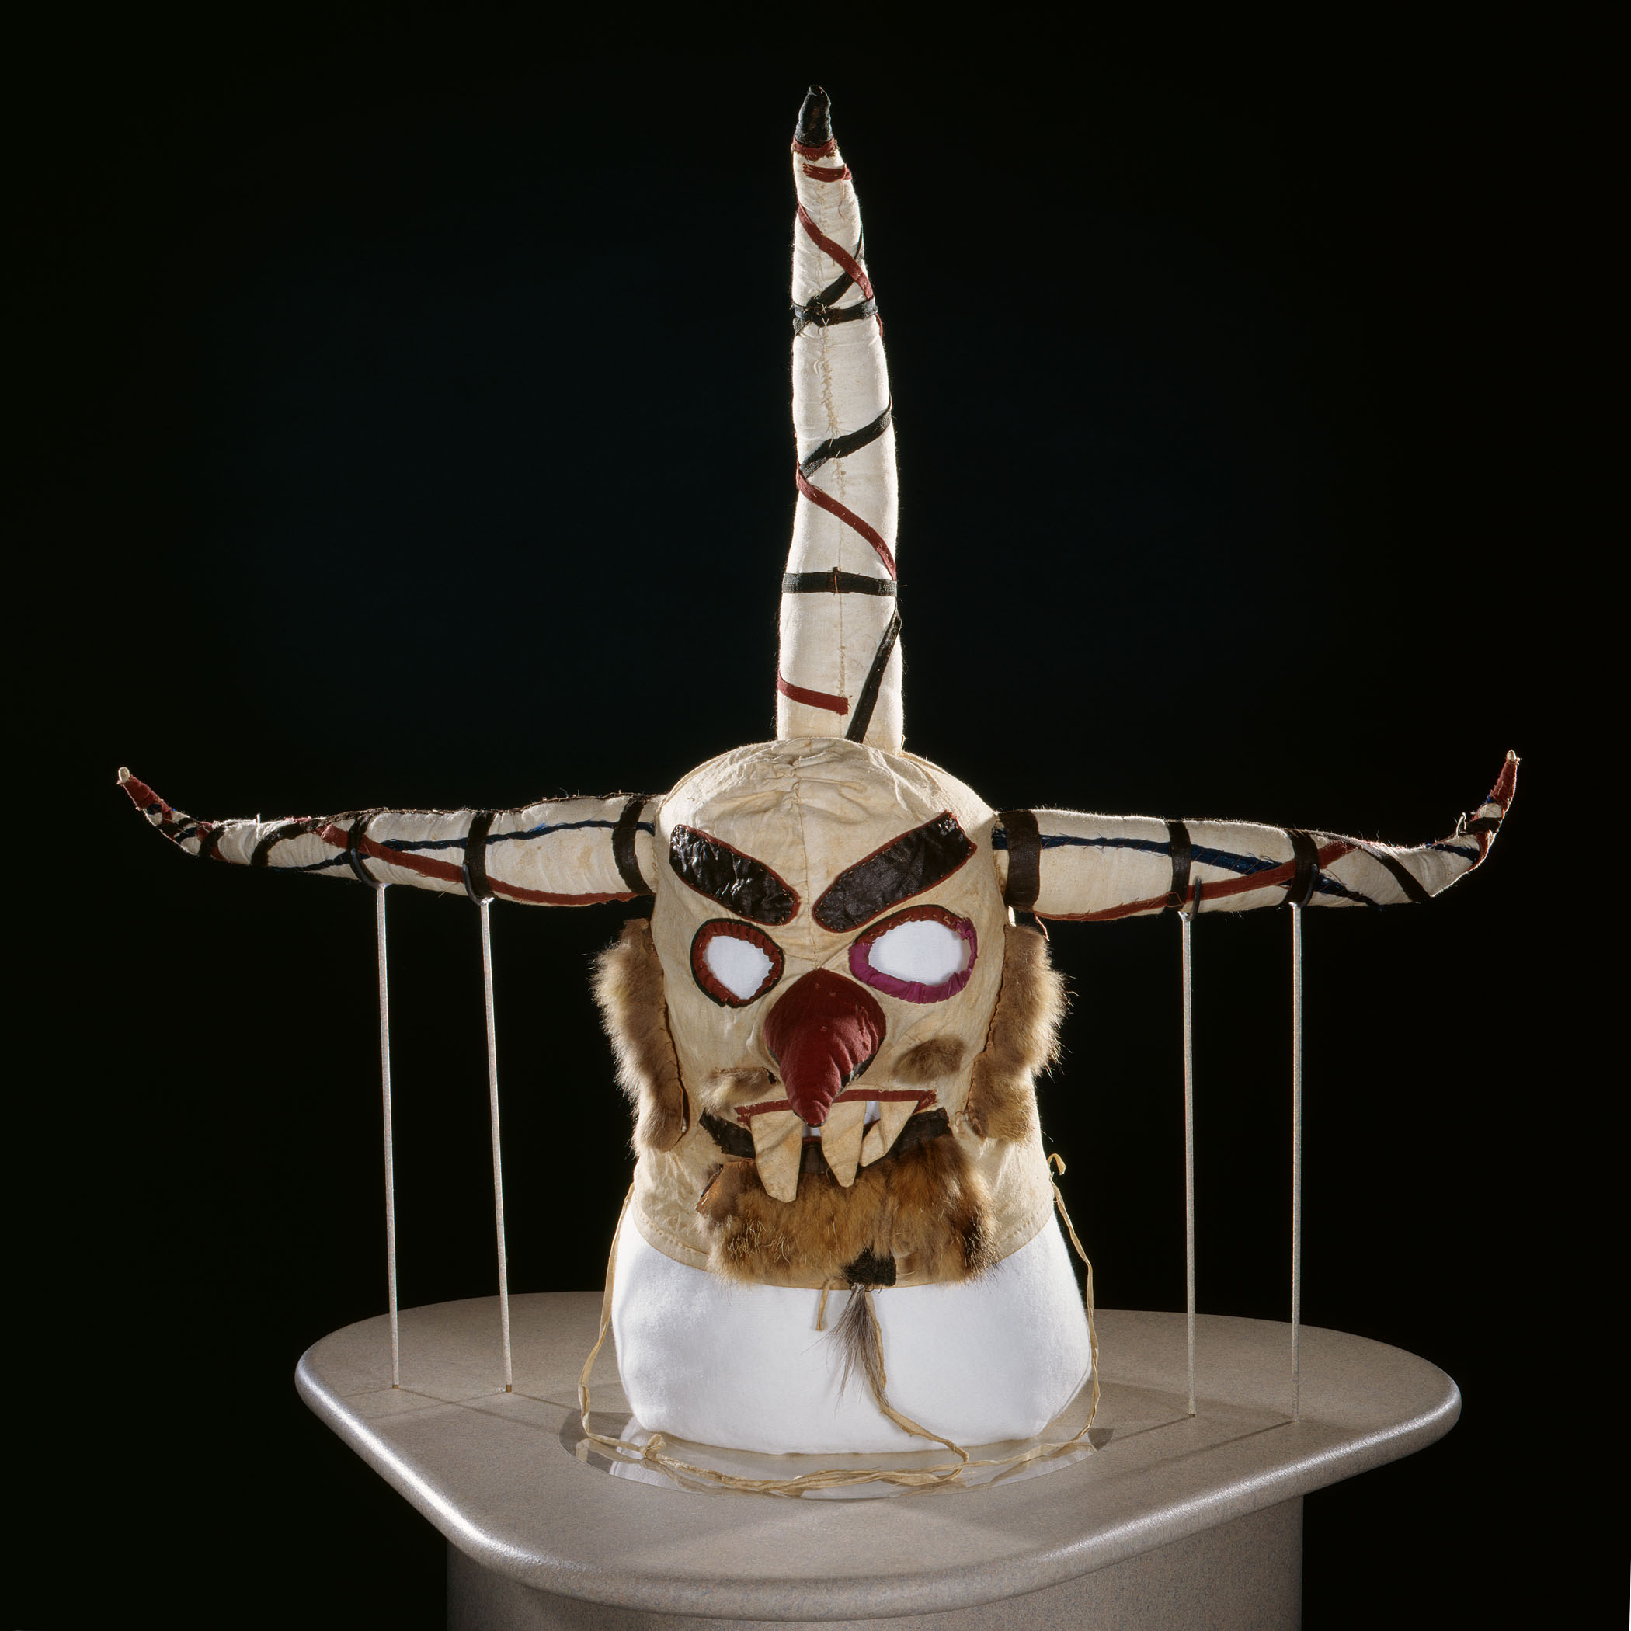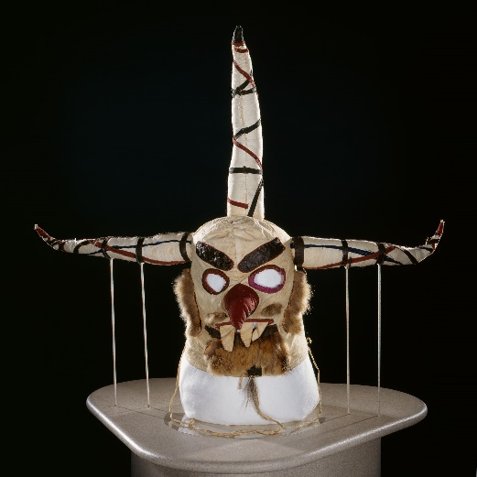

**Interactive Gallery Activities**

In order to ensure students truly engage with museum content and think critically about the information and artifacts they encounter, teachers can provide the following activity assignments prior to the class visit. While each activity culminates in a group project to be completed post-visit, each student will be individually responsible for collecting information from a particular gallery while at the museum. While students should be given time to freely tour through the entire exhibit, each activity is designed so that their final project will focus on one particular gallery in order to make the information presented more manageable for students. (Teachers should feel free to edit the activities to focus on a particular theme, time period, topic, etc., instead of a gallery, should such a format better meet their educational and curricular goals.)

While the information students will collect for each activity is similar, the deliverables range from a theatrical performance to a print advertisement. It is important students have class time before their visit to review the information they will be collecting, as the success of the final projects is based upon the quality of information the students gather during their visit.

Teachers should edit each activity as they see fit, omitting, adding and altering questions as needed. While these activities are written as group assignments, they can be altered to be assigned as individual or partner work. Teachers should determine whether to assign all students the same activity, or whether to have different groups work on different activities. (For example, all students might be assigned the Tar Heel Players activity, with each group focusing on a different gallery. The final projects will then be a series of performances, with each focused on a different gallery. This can provide an excellent review of the museum visit, as well as an engaging platform for further discussion and learning.) Teachers should determine how much class time and homework time will be provided for project completion. **Student handouts for each of the following activities can be found at the end of this document.**

* Carolina Advertising: Students will assume the roles of advertising professionals who have been hired to create a print advertisement campaign for an assigned gallery.
* Carolina Commercials: Students will create an infomercial for an assigned gallery.
* Museum Education Association: Students will imagine they are part of an association of museum educators whose job is to create fun and educational lesson plans based on particular exhibits. They will design a lesson plan for elementary school students to teach them about the information from an assigned gallery.
* The Tar Heel Players: Pretending they are part of a successful theatre troupe, students will create a 5 minute performance that dramatizes the information found in their gallery.
* Tar Heel Technology Group: As employees of a successful web design group, students will create a website that summarizes the information found from their gallery. This activity instructs students to take pictures of various artifacts while touring, thus a camera (or a cell phone with a camera) will be needed.
* An exhibit map and guide for *The Story of North Carolina*, which will provide the titles of the various galleries and an overview of the topics/content covered in each, are available here: <http://www.ncdcr.gov/ncmoh/Learn/ForEducators/PlanaMuseumFieldTrip/PrevisitMaterials.aspx>

**North Carolina History is Boring…NOT!**

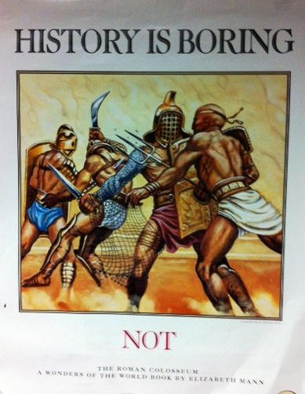

To help students debrief and review the information they encountered in the exhibit, instruct students to create a historical poster with the title, “History is boring…NOT!” Students should consider the various historical events addressed in *The Story of North Carolina*, many of which are filled with drama, intrigue and excitement. For example, when you consider the actions of North Carolina’s Regulators, an organization of colonial protestors considered by many of the time to be a violent mob, history proves to be anything but boring. Based on what they learned from *The Story of North Carolina* (and perhaps additional research post-visit), students should choose one event to illustrate in such a way that the exciting, interesting, dramatic, etc. aspects of such history are highlighted. The poster should contain the text “History is Boring…NOT!,” and include original artwork depicting the chosen history, as well as a short description of the event. Students can be creative in the overall design and look of the poster.

**Design an Advertisement**

The North Carolina Museum of History has hired you as their new marketing director! Your first assignment on the job is to design a new poster for advertising *The Story of North Carolina* and boosting visitation. Now that you have toured the exhibit, consider what you can highlight about it that would encourage others to visit.

Your final poster should:

* + Include visuals such as art work, pictures, symbols, etc. that represent *The Story of North Carolina* (can be literal or abstract)
* Contain text or phrases that offer interesting, “teaser” information about the exhibit
* Be effective in recruiting future visitors
* Be creative, colorful, and show that that the creator of the poster put forth thought, time, and effort into the design

**Hashtag History**

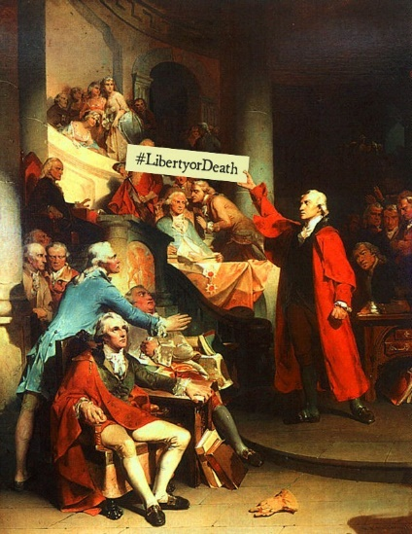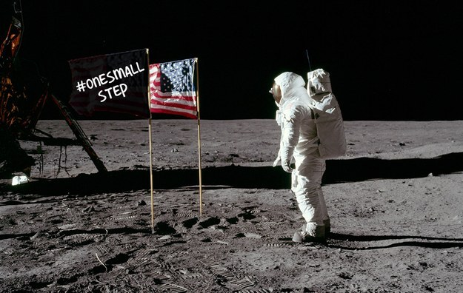Provide students with various images from history and instruct them to create a hashtag that summarizes what is being depicted in a concise and creative way. (To further enhance the art component of the activity, rather than providing images, instruct students to illustrate the historical event themselves then add their hashtag.)

*Additional examples:* [*http://www.buzzfeed.com/katherinemiller/what-us-history-would-have-been-like-with-hashtags*](http://www.buzzfeed.com/katherinemiller/what-us-history-would-have-been-like-with-hashtags)

**Living Museum Exhibit**

In partners or groups, students will create a “living” museum exhibit that further explores a topic, person, event, theme, etc. from *The Story of North Carolina*. (**The student handout for this activity can be found at the end of this document.**)

Determine the subject matter of each group’s living museum exhibit, then explain the requirements of their exhibit:

* *A statue/visual representation of topic assigned to you*: Students should take turns playing “clay” and the role of “sculptor”, sharing ideas and using their bodies to create a statue or statuesque image that represents the topic assigned. The final statue/image must include at least one student of the partnership/group, but can also include additional students, props, costumes, etc., and can be literal or abstract. The only requirement is that the final product is a visual representation of the assigned topic/event/person, and it must be a product the can be held in place for a short period of time.
* *A verbal presentation about your statue/visual representation:* When visitors walk up to the exhibit, the museum docent (tour guide) should be able to tap the image, resulting in information about the exhibit being shared. This information will be shared by one or more students in the group (in character), and should be approximately 1-2 minutes long. (For example, a sculpture might come alive to tell his/her story in first person, or perhaps the sculpture remains frozen with one of the students assuming the role of a narrator who delivers information.) Once the information is shared, the exhibit returns to the position it was originally in.

Allow students to prepare their museum exhibit. (Time will vary based on class composition and teacher’s pacing). Once all students are finished, ask half of the class partners to assume the position of their exhibits, and instruct the other half of the class to join you. The teacher should now assume the personality of a museum docent, taking half the class on an “art walk.” Lead students to each of their classmates “living” exhibits and ask them:

* What do you see here?
* Why do you think the artist has placed the clay in this position? What might this represent? What message is the artist is trying to convey?

Once students have discussed their predictions of the piece, the teacher should tap the exhibit to “bring it to life,” at which point the student(s) will share the information they have compiled about their topic in whatever creative way they have chosen. Afterwards, the tour will continue on to the next piece of art. (Once a student’s exhibit has been visited, they can join the tour as well. Also, students can relax their statue positions while they are waiting for the tour to arrive at their exhibit.) As students tour, teachers may want to have them take notes on each exhibit they view. Feedback can be based on particular questions, or general questions such as “What I liked” and “What I learned.”

Once all sculptures have been viewed, the class should swap places, with all students who presented their exhibits now becoming tourists, and the students who took the tour now assuming the positions for their exhibit. Repeat the same touring process.

* *Teacher note:* Teachers should use their discretion regarding how much class and/or homework time to devote to the museum activity. The process can be drawn out and turned into a project, in which students take several days (class and homework time) to research, prepare their exhibit, come to class dressed as their parts, etc. Or, it can be done in class as a quicker, one-day activity.

**Museum Advocacy Speech**

Should the government provide funding for state museums such as the North Carolina Museum of History, Museum of Art or Museum of Natural Sciences? Pretend you are a Representative in the General Assembly. Write a 2 minute speech declaring your opinion regarding this question to deliver to your fellow legislators, based on your experience having recently visited the museum. Questions to consider when planning your speech:

* What was your experience like at the museum?
* What did you learn when you visited this state-supported museum?
* What is the purpose of museums and exhibits such as *The Story of North Carolina*?
* Who benefits from such museums and exhibits?
* What does a museum and exhibit like this do for history, art, and science education?

Your speech should state whether you feel museum funding is important for our state and why. What benefits do we gain or lose through providing government funds to cultural organizations such as the North Carolina Museum of History? Be prepared to deliver your 2 minute speech to class.

**Post-visit discussion questions**

* What was the most interesting display and why?
* What did the exhibit leave out? What should be added and why?
* What did you see or learn that was entirely new to you?
* What did the exhibit curators do well in terms of the exhibit’s content and design? Was the information clearly presented? Did you understand the exhibit’s main points and themes?
* What needs to be improved and why?
* Can you think of a particular display that you would design differently, specifically with the purpose of better engaging young people? Explain.
* What techniques did museum staff use to try and engage you with the material?
* How were the various artifacts and displays placed throughout the exhibit? What was emphasized? Which artifacts do you think were most important? What did the museum staff do to highlight particular artifacts or pieces of information over others?
* What themes did you identify throughout the exhibit?
* What was the overall purpose of the exhibit? What do you think the curators wanted you to “take away?”
* What role do museums play in our society? Why is it important for people to visit museums such as the North Carolina Museum of History?

**Carolina Advertising**

**Gallery Assignment: __________________________________________________________**

**Group Members: _____________________________________________________________**

Imagine that you are part of a premiere advertising company, Carolina Advertising. Your group has been hired to create a print advertisement campaign for your assigned gallery that includes a poster or a billboard and a 1-2 minute radio spot. Circulate around the gallery and pay close attention to the artifacts & their descriptions, primary and secondary sources, images, art, and other items displayed. Consider the questions and tasks below and take detailed notes - you will use this information back in the classroom to create your ad campaign.

1. Glance around the gallery. What words or phrases first come to mind? What objects, images, etc. do you first notice & why?
2. Which artifacts seem to be most important in this room? What did the curators do to make you think they are the most important? Which artifacts or pieces of information in this room are most interesting to you personally and why?
3. As you circulate, closely examine the artifacts and information presented. Choose 1 artifact to summarize:

|  |  |
| --- | --- |
| Artifact description:  What would the purpose of this artifact have been?  What history does this artifact highlight?  Why do you think it is included in this exhibit? | Sketch the artifact: |

1. Examine the displays (pairings or groupings of artifacts) within the gallery. Choose 1 display to summarize:

* List & describe the elements of the display (the artifacts, images, etc. it contains)
* Which parts of the display are given more emphasis and in what way? Why do you think this is the case?
* What is the focus and/or purpose of this display? What is it trying to convey to visitors?

1. List five interesting things you learned from this gallery.
2. What overall story is being told (or what overall lesson is being taught) in this gallery?
3. Why do you think the gallery was given its particular title? If you were to rename it, what would you call this gallery and why?

|  |
| --- |
| As a member of Carolina Advertising, you will work with your group to create a poster or a billboard and a 2-3 minute radio spot that uses the important information from this gallery and/or additional details on the events, people, places, etc. you learned about to educate the public about this history and to encourage them to visit.   * Your **poster or billboard** should be informational and educational. It must contain relevant artwork, descriptive text, and a tag line (a catchphrase, or small amount of eye catching/interesting text). It should also be artistic and creative. * You **radio spot** should be approximately 1-2 minutes when spoken and should also educate and inform listeners regarding your assigned gallery. Listeners should be so interested by what you share that they are convinced to visit the museum themselves. Your radio spot can make use of any creative techniques you choose (dramatic voices, humor, song/music, a skit, etc.), as long as it contains accurate information from the gallery. |

**C:\Users\crhinson\AppData\Local\Microsoft\Windows\Temporary Internet Files\Content.IE5\2AW29CFC\MC900334230[1].wmf**

**Carolina Commercials**

**Gallery Assignment: __________________________________________________________**

**Group Members: _____________________________________________________________**

Imagine that you are part of a premiere advertising company, Carolina Commercials. Your group has been hired to create an infomercial for your assigned gallery. Circulate around the gallery and pay close attention to the artifacts & their descriptions, primary and secondary sources, images, art, and other items displayed. Consider the questions and tasks below and take detailed notes - you will use this information back in the classroom to create your script & infomercial.

1. Glance around the gallery. What words or phrases first come to mind? What objects, images, etc. do you first notice & why?
2. Which artifacts seem to be most important in this room? What did the curators do to make you think they are the most important? Which artifacts or pieces of information in this room are most interesting to you personally and why?
3. As you circulate, closely examine the artifacts and information presented. Choose 1 artifact to summarize:

|  |  |
| --- | --- |
| Artifact description:  What would the purpose of this artifact have been?  What history does this artifact highlight?  Why do you think it is included in this exhibit? | Sketch the artifact: |

1. Examine the displays (pairings or groupings of artifacts) within the gallery. Choose one display to summarize:

* List & describe the elements of the display (the artifacts, images, etc. it contains)
* Which parts of the display are given more emphasis and in what way? Why do you think this is the case?
* What is the focus and/or purpose of this display? What is it trying to convey to visitors?

1. List five interesting things you learned from this gallery.
2. What overall story is being told (or what overall lesson is being taught) in this gallery?
3. Why do you think the gallery was given its particular title? If you were to rename it, what would you call this gallery and why?

|  |
| --- |
| As a member of Carolina Commercials, you will work with your group to create a 5 minute performance that summarizes the important information from this gallery and/or provides additional details on the events, people, places, etc. you learned about. Your infomercial can utilize acting, music/singing, reenactments, dance, and any other creative techniques you choose. It should be 3 or more minutes when performed. Begin to brainstorm ideas here: |

C:\Users\crhinson\AppData\Local\Microsoft\Windows\Temporary Internet Files\Content.IE5\OH4NX70L\MC900056680[1].wmf**Museum Education Association**

**Gallery Assignment: __________________________________________________________**

**Group Members: _____________________________________________________________**

Imagine that you are part of an association of museum educators whose job is to create fun and educational lesson plans based on particular exhibits. Your group has been hired to create a lesson plan for elementary school students to teach them about the information from your assigned gallery. Circulate around the gallery and pay close attention to the artifacts & their descriptions, primary and secondary sources, images, art, and other items displayed. Consider the questions and tasks below and take detailed notes - you will use this information back in the classroom to create your lesson plan.

1. Glance around the gallery. What words or phrases first come to mind? What objects, images, etc. do you first notice & why?
2. As you circulate, closely examine the artifacts and information presented. Choose one artifact to summarize:

|  |  |
| --- | --- |
| Artifact description:  What would the purpose of this artifact have been?  What history does this artifact highlight?  Why do you think it is included in this exhibit? | Sketch the artifact: |

1. Which artifacts or pieces of information in this room are most interesting to you personally and why?
2. What artifact or information from this gallery do you think would be most interesting to an elementary school student and why?
3. Examine the displays (pairings or groupings of artifacts) within the gallery. Choose one display to photograph and summarize:

* List & describe the elements of the display (the artifacts, images, etc. it contains)
* Which parts of the display are given more emphasis and in what way? Why do you think this is the case?
* What is the focus and/or purpose of this display? What is it trying to convey to visitors?

1. List five interesting things you learned from this gallery overall.
2. What overall story is being told (or what overall lesson is being taught) in this gallery?
3. Why do you think the gallery was given its particular title? If you were to rename it, what would you call this gallery and why?

|  |
| --- |
| As a member of the *Museum Education Association*, you will your notes to work with your group and create a lesson plan for an elementary school class that teaches them about the important information from this gallery and the events, people, places, etc. you learned about. Your lesson plan must include:   * Introduction: Provide the students with background information about the topic of your lesson. Try to stimulate their interest and encourage thinking. There are many ways you can introduce students to what you want them to learn (lecture, video clips, discussion questions, anecdotes, thought-provoking dilemma, etc.) * An in class activity: Get the students to apply what they have learned in a fun way! Consider how you might use art, group work, a learning game, etc. to engage the kids.) * Homework: Create an assignment that will allow students to reflect on what they have learned. This might be a writing prompt, a worksheet, a creative activity, etc.   Begin brainstorming ideas here: |

C:\Users\crhinson\AppData\Local\Microsoft\Windows\Temporary Internet Files\Content.IE5\9Q4101LC\MC900021360[1].wmf

**The Tar Heel Players**

**Gallery Assignment: __________________________________________________________**

**Group Members: _____________________________________________________________**

Imagine that you are part of a successful theatre troupe called “The Tar Heel Players.” Your group has been hired to create a 5 minute performance that dramatizes the information found in your assigned gallery. Circulate around the gallery and pay close attention to the artifacts & their descriptions, primary and secondary sources, images, art, and other items displayed. Consider the questions and tasks below and take detailed notes - you will use this information back in the classroom to create your script & performance.

1. Glance around the gallery. What words or phrases first come to mind? What objects, images, etc. do you first notice & why?
2. Which artifacts seem to be most important in this room? What did the curators do to make you think they are the most important? Which artifacts or pieces of information in this room are most interesting to you personally and why?
3. As you circulate, closely examine the artifacts and information presented. Choose one artifact to summarize:

|  |  |
| --- | --- |
| Artifact description:  What would the purpose of this artifact have been?  What history does this artifact highlight?  Why do you think it is included in this exhibit? | Sketch the artifact: |

1. Examine the displays (pairings or groupings of artifacts) within the gallery. Choose one display to summarize:

* List & describe the elements of the display (the artifacts, images, etc. it contains)
* Which parts of the display are given more emphasis and in what way? Why do you think this is the case?
* What is the focus and/or purpose of this display? What is it trying to convey to visitors?

1. List five interesting things you learned from this gallery.
2. What overall story is being told (or what overall lesson is being taught) in this gallery?
3. Why do you think the gallery was given its particular title? If you were to rename it, what would you call this gallery and why?

|  |
| --- |
| As a member of the famous *Tar Heel Players*, you will work with your group to create a 5 minute performance that summarizes the important information from this gallery and/or provides additional details on the events, people, places, etc. you learned about. Your performance can utilize acting, music/singing, reenactments, dance, and any other theatrical techniques you choose. Begin to brainstorm ideas for your performance and what to include: |

**Tar Heel Technology Group**

**Gallery Assignment: __________________________________________________________**

**Group Members: _____________________________________________________________**

Imagine that you are part of a successful web design group called *The Tar Heel Technology Group*. Your group has been hired to create a website that summarizes the information found in your assigned gallery in an educational and engaging way. Circulate around the gallery and pay close attention to the artifacts & their descriptions, primary and secondary sources, images, art, and other items displayed. Consider the questions and tasks below and take detailed notes. Use your camera to take pictures of important & interesting exhibit aspects. You will use this information back in the classroom to create your website design.

1. Glance around the gallery. What words or phrases first come to mind? What objects, images, etc. do you first notice & why?
2. Circulate around the gallery then use your camera to take a picture of 4 or more artifacts that you think are most important. List and describe them.

|  |  |
| --- | --- |
| *Artifact description:*  *What would the purpose of this artifact have been?*  *What history does this artifact highlight?*  *Why do you think it is included in this exhibit?* | *Artifact description:*  *What would the purpose of this artifact have been?*  *What history does this artifact highlight?*  *Why do you think it is included in this exhibit?* |
| *Artifact description:*  *What would the purpose of this artifact have been?*  *What history does this artifact highlight?*  *Why do you think it is included in this exhibit?* | *Artifact description:*  *What would the purpose of this artifact have been?*  *What history does this artifact highlight?*  *Why do you think it is included in this exhibit?* |

1. Which artifacts or pieces of information in this room are most interesting to you personally and why? If not listed in #2, take a picture of the artifact and include a description here.
2. Examine the displays (pairings or groupings of artifacts) within the gallery. Choose one display to photograph and summarize:

* List & describe the elements of the display (the artifacts, images, etc. it contains)
* Which parts of the display are given more emphasis and in what way? Why do you think this is the case?
* What is the focus and/or purpose of this display? What is it trying to convey to visitors?

1. List five interesting things you learned from this gallery overall.
2. What overall story is being told (or what overall lesson is being taught) in this gallery?
3. Why do you think the gallery was given its particular title? If you were to rename it, what would you call this gallery and why?

|  |
| --- |
| As a member of the *Tar Heel Technology Group*, you will use the pictures you took and your notes to work with your group and create a webpage that summarizes the important information from this gallery and/or provides additional details on the events, people, places, etc. you learned about. Your final page can be created on poster board or electronically. Your page must contain:   * a title * at least 6 photos that you took from the gallery and accompanying descriptions written by your group * information that encourages page viewers to want to learn more, to visit the gallery themselves, and to understand why this history is important * a creative & thematic design |

**Create a Living Museum Exhibit**

**Gallery Assignment: __________________________________________________________**

**Group Members: _____________________________________________________________**

Imagine that you have been hired to make *The Story of North Carolina* a more interactive exhibit. The way you will do this is by creating a “living exhibit,” an exhibit that will contain sculptures (which will be yourselves, frozen in place) that when touched will “come to life” and share information with the visitor. Circulate around the gallery and pay close attention to the artifacts & their descriptions, primary and secondary sources, images, art, and other items displayed. Consider the questions and tasks below and take detailed notes - you will use this information back in the classroom to create your living exhibit.

1. Glance around the gallery. What words or phrases first come to mind? What objects, images, etc. do you first notice & why?
2. Which artifacts seem to be most important in this room? What did the curators do to make you think they are the most important? Which artifacts or pieces of information in this room are most interesting to you personally and why?
3. As you circulate, closely examine the artifacts and information presented. Choose one artifact to summarize:

|  |  |
| --- | --- |
| Artifact description:  What would the purpose of this artifact have been?  What history does this artifact highlight?  Why do you think it is included in this exhibit? | Sketch the artifact: |

1. Examine the displays (pairings or groupings of artifacts) within the gallery. Choose one display to summarize:

* List & describe the elements of the display (the artifacts, images, etc. it contains)
* Which parts of the display are given more emphasis and in what way? Why do you think this is the case?
* What is the focus and/or purpose of this display? What is it trying to convey to visitors?

1. List five interesting things you learned from this gallery.
2. What overall story is being told (or what overall lesson is being taught) in this gallery?
3. Why do you think the gallery was given its particular title? If you were to rename it, what would you call this gallery and why?

|  |
| --- |
| Choose a topic from your gallery and begin to brainstorm your “living museum exhibit.” Your final exhibit must include:   * *A statue/visual representation of your topic*: Students should take turns playing “clay” and the role of “sculptor”, sharing ideas and using their bodies to create a statue or statuesque image that represents the topic assigned. The final statue/image must include at least one student of the partnership/group, but can also include additional students, props, costumes, etc., and can be literal or abstract. The only requirement is that the final product is a visual representation of the assigned topic/event/person, and it must be a product the can be held in place for a short period of time. * *A verbal presentation about your statue/visual representation:* When visitors walk up to the exhibit, the museum docent (tour guide) should be able to tap the image, resulting in information about the exhibit being shared. This information will be shared by one or more students in the group (in character), and should be approximately 1-2 minutes long. (For example, a sculpture might come alive to tell his/her story in first person, or perhaps the sculpture remains frozen with one of the students assuming the role of a narrator who delivers information.) Once the information is shared, the exhibit returns to the position it was originally in. |